WEEK 3: Spring Core Maven Exercises (Solutions)
Exercise 1: Configuring a Basic Spring Application:
Scenario:
Your company is developing a web application for managing a library. You need to use the Spring Framework to handle the backend operations.
Steps:
- Set Up a Spring Project:
  - Create a Maven project named LibraryManagement.
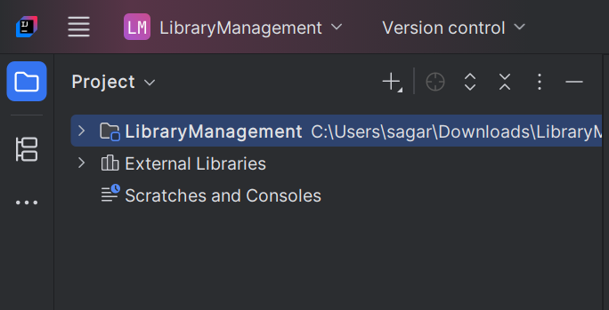
  - Add Spring Core dependencies in the pom.xml file.
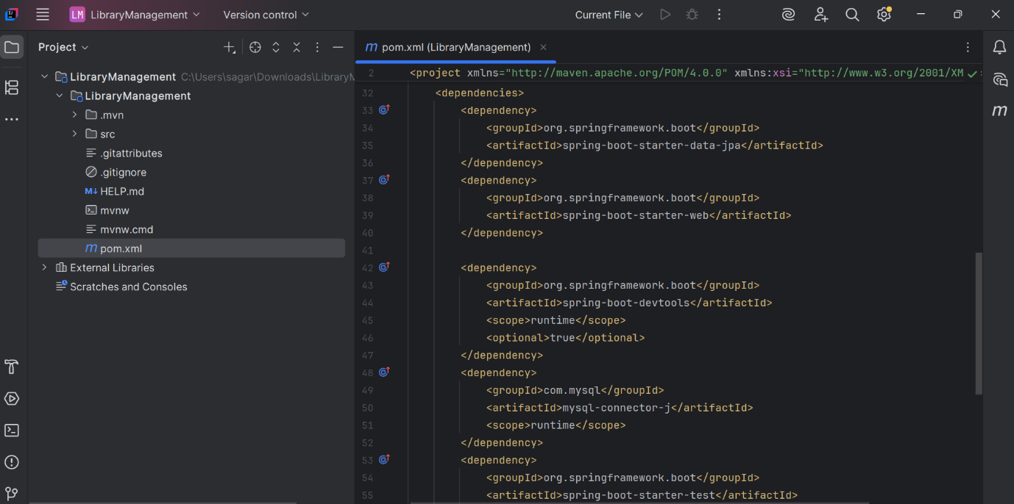

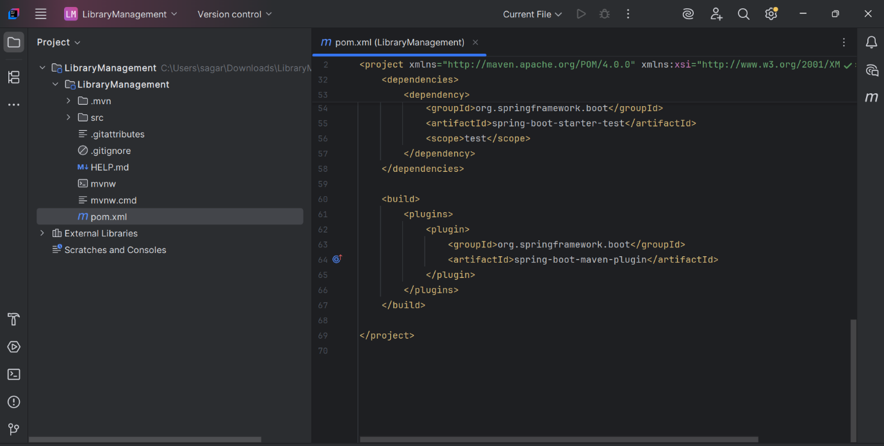

- Configure the Application Context:
  - Create an XML configuration file named applicationContext.xml in the src/main/resources directory.
  - Define beans for BookService and BookRepository in the XML file.
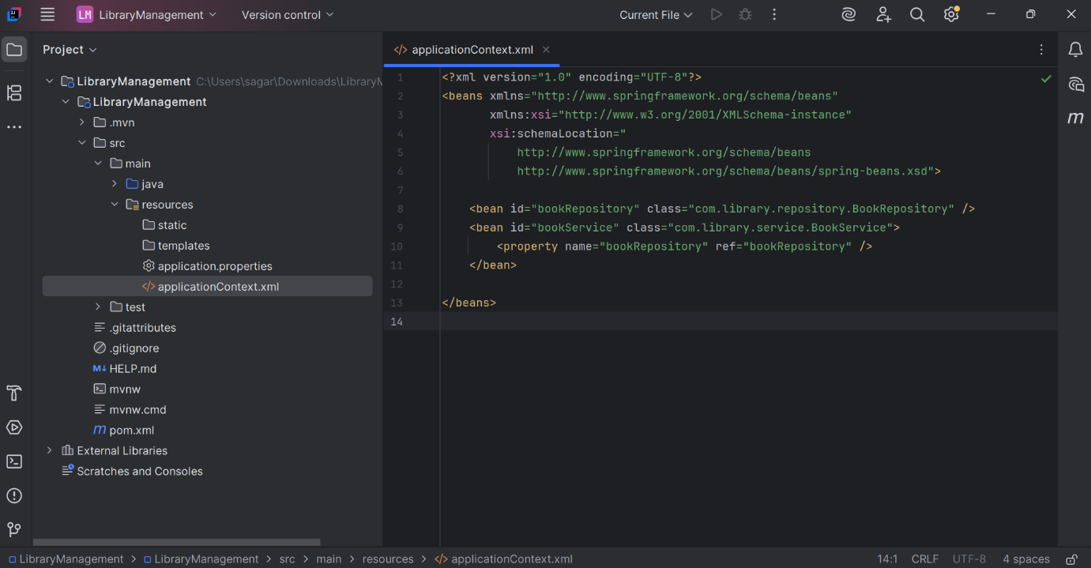

- Define Service and Repository Classes:
  - Create a package com.library.service and add a class BookService.
  - Create a package com.library.repository and add a class BookRepository.
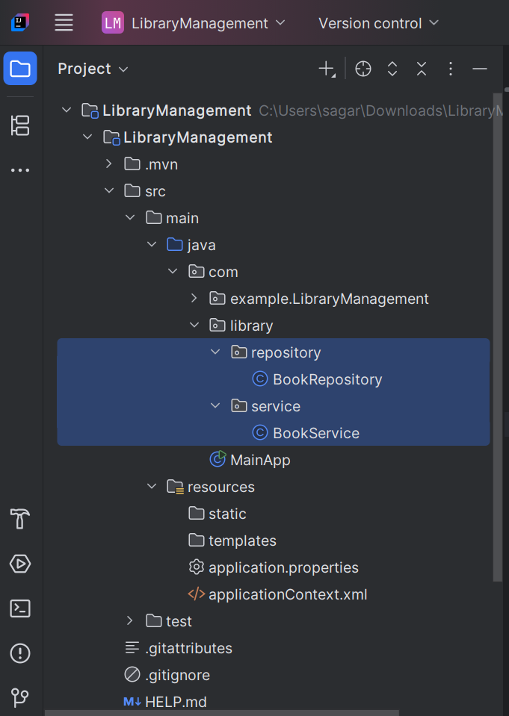

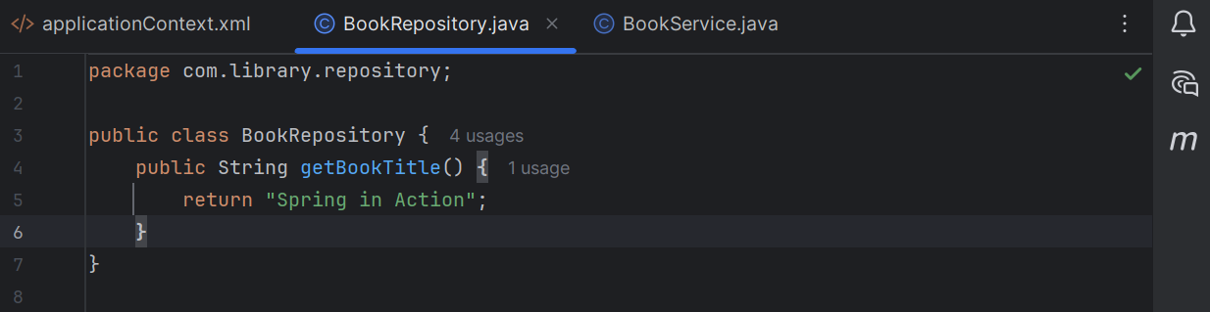

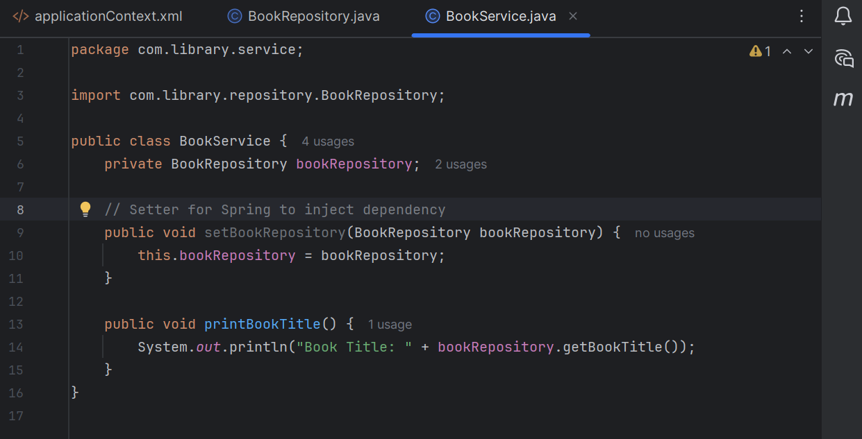

- Run the Application:
  - Create a main class to load the Spring context and test the configuration.
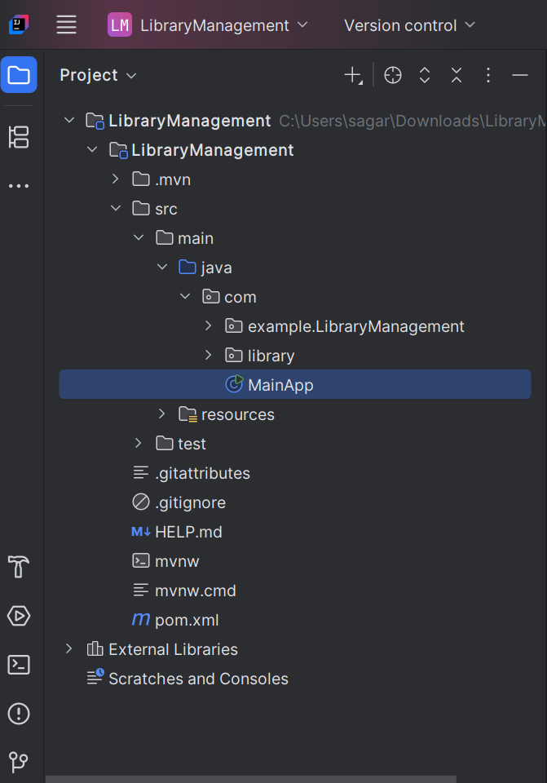
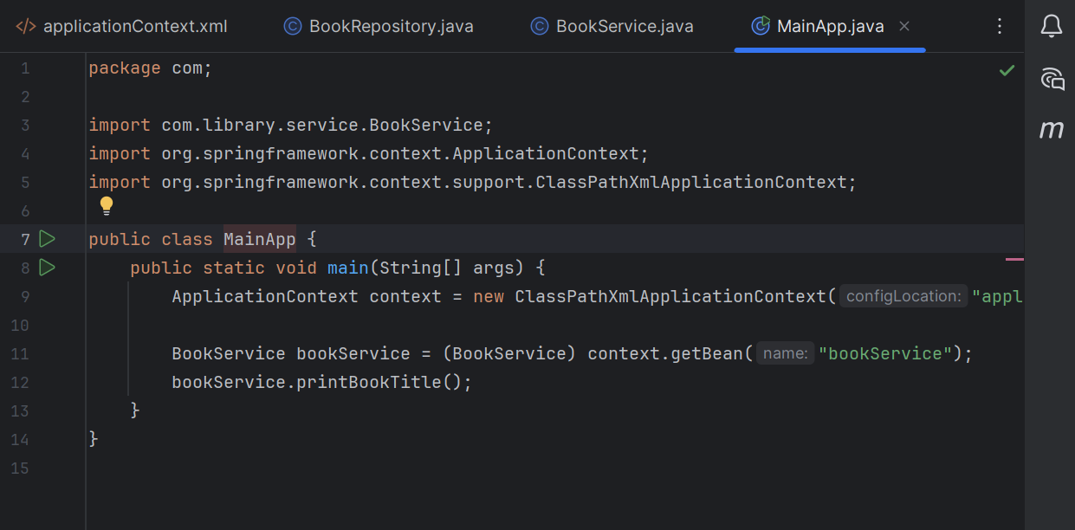

OUTPUT:

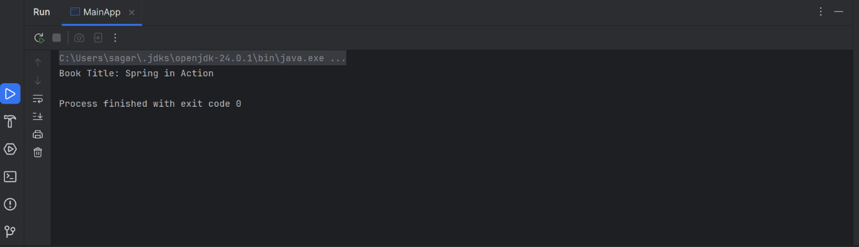

==================================================================================

Exercise 2: Implementing Dependency Injection

Scenario:
In the library management application, you need to manage the dependencies between the BookService and BookRepository classes using Spring's IoC and DI.

Project Structure

LibraryManagement/
├── src/
│ ├── main/
│ │ ├── java/
│ │ │ └── com/
│ │ │ └── library/
│ │ │ ├── MainApp.java
│ │ │ ├── repository/
│ │ │ │ └── BookRepository.java
│ │ │ └── service/
│ │ │ └── BookService.java
│ │ └── resources/
│ │ └── applicationContext.xml
└── pom.xml

Steps:
- Modify the XML Configuration:
  - Update applicationContext.xml to wire BookRepository into BookService.
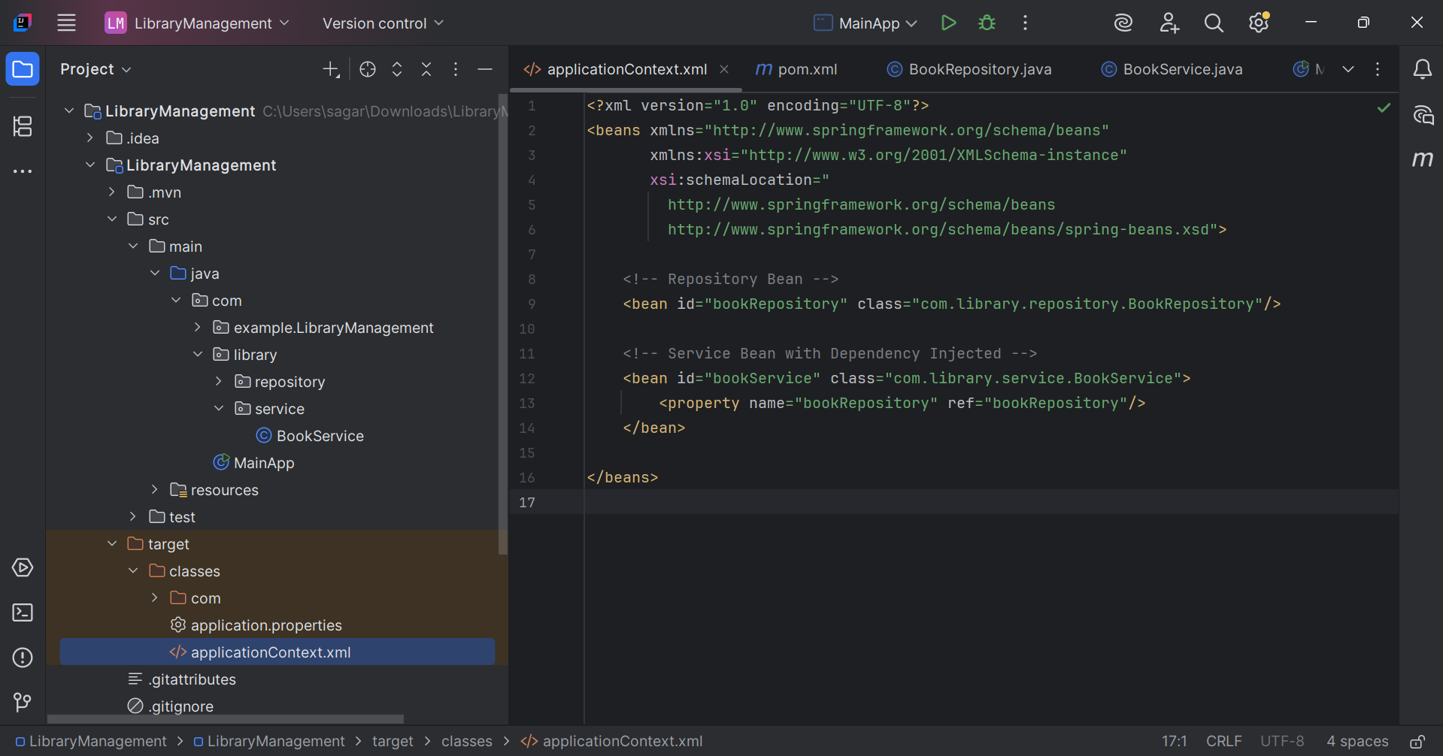

- Update the BookService Class:
  - Ensure that BookService class has a setter method for BookRepository

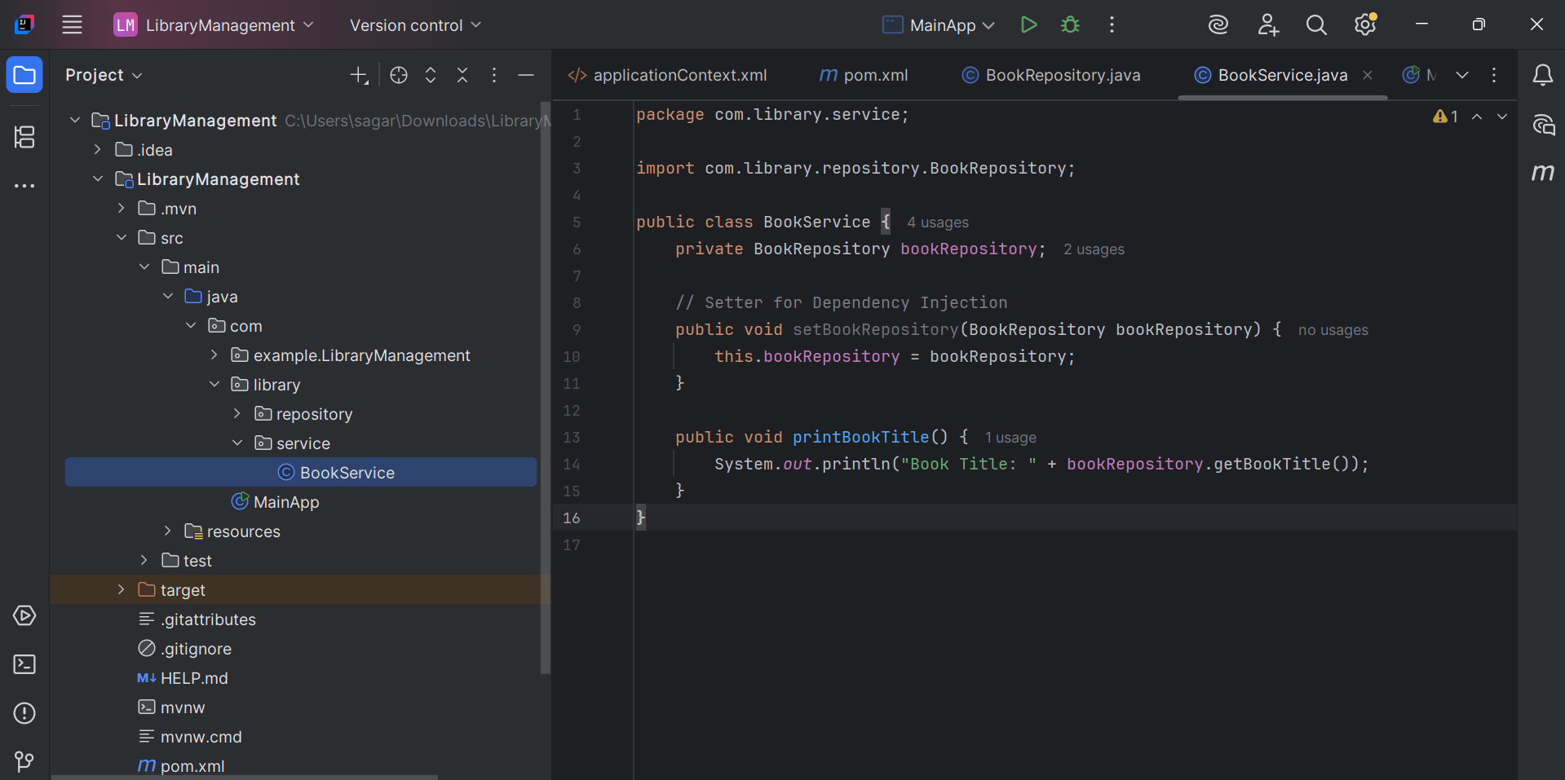

- Test the Configuration:
  - Run the LibraryManagementApplication main class to verify the dependency injection.
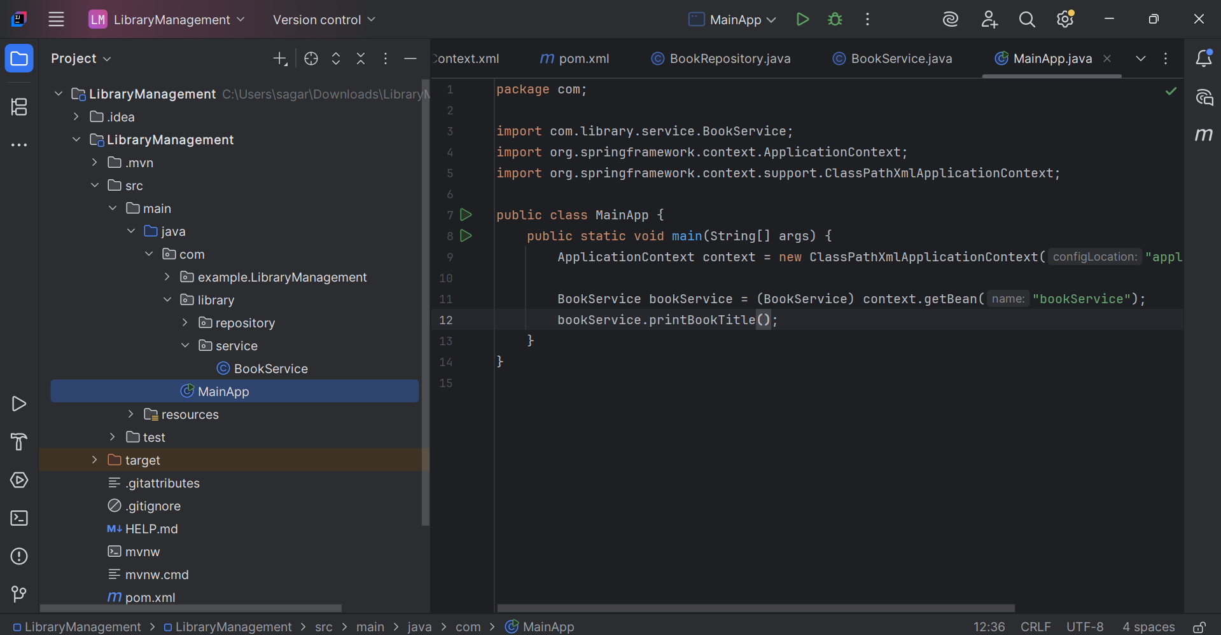

OUTPUT:

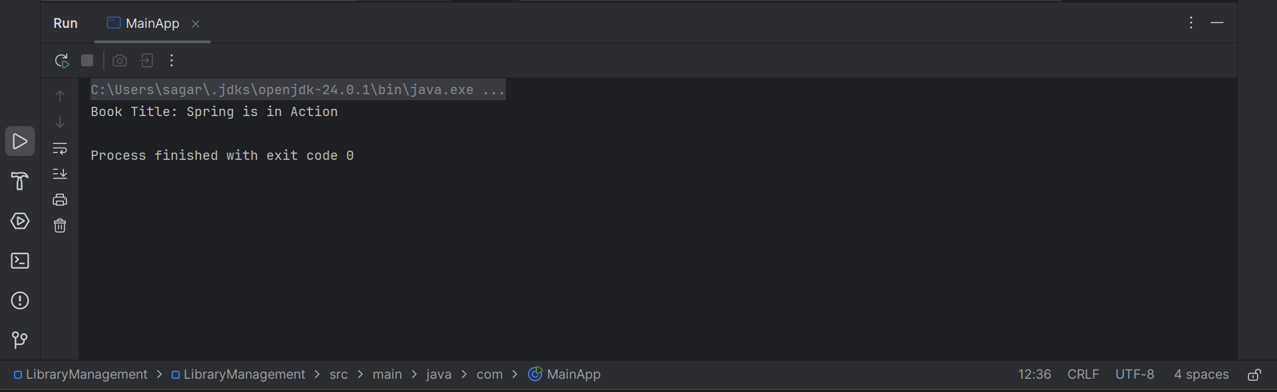

===========================================================================

Exercise 4: Creating and Configuring a Maven Project

Scenario:
You need to set up a new Maven project for the library management application and add Spring dependencies.
Steps:

- Create a New Maven Project:
  - Create a new Maven project named LibraryManagement.
- Add Spring Dependencies in pom.xml:
  - Include dependencies for Spring Context, Spring AOP, and Spring WebMVC.

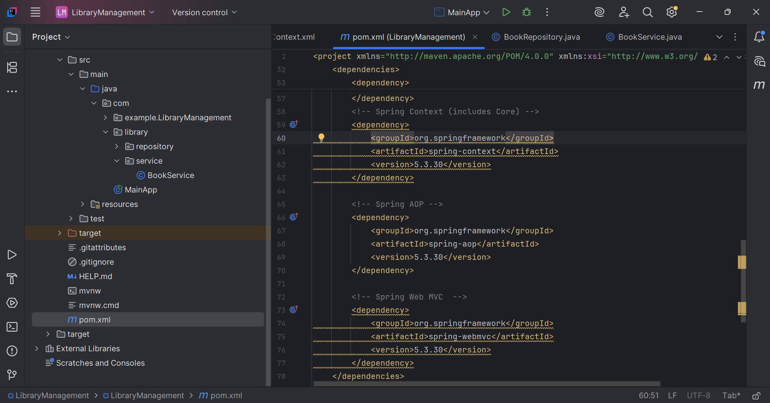

- Configure Maven Plugins:
  - Configure the Maven Compiler Plugin for Java version 1.8 in the pom.xml file.




